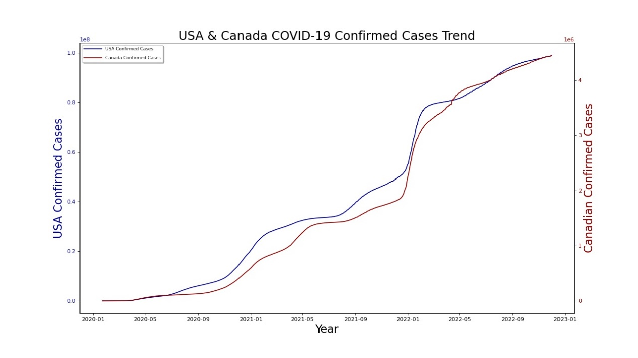 The USA and Canada's COVID-19 Confirmed Cases are shown on this graph.

Confirmed cases in the USA are depicted by the blue line, while those in Canada are represented by the red line.

beginning in 2020 to 2023, USA & Canada COVID-19 Confirmed Cases.

Slightly started in 2020 and quickly increased in 2023.

Almost identical COVID-19 confirmed cases are present in both countries’ scenario.

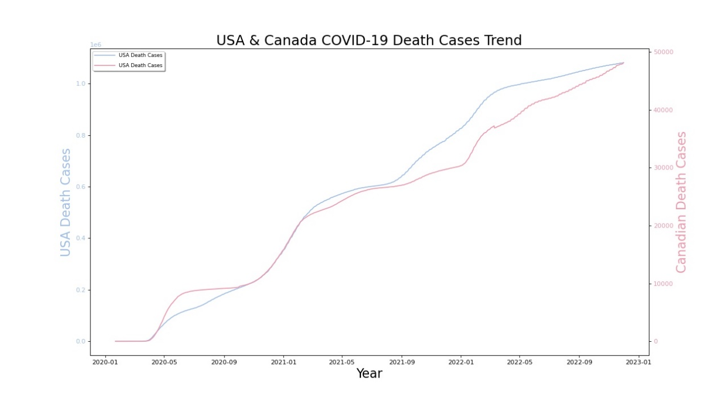

The COVID-19 Death Cases for the USA and Canada are shown in this graph.

USA death cases are depicted by the blue line, and Canadian death cases are represented by the red line.

Beginning in 2020 through 2023, COVID-19 Death Cases in the USA & Canada. Slightly began Death Cases in both countries in 2020.

Following a year of comparable increases in both countries, the number of deaths in the USA surged sharply in 2023.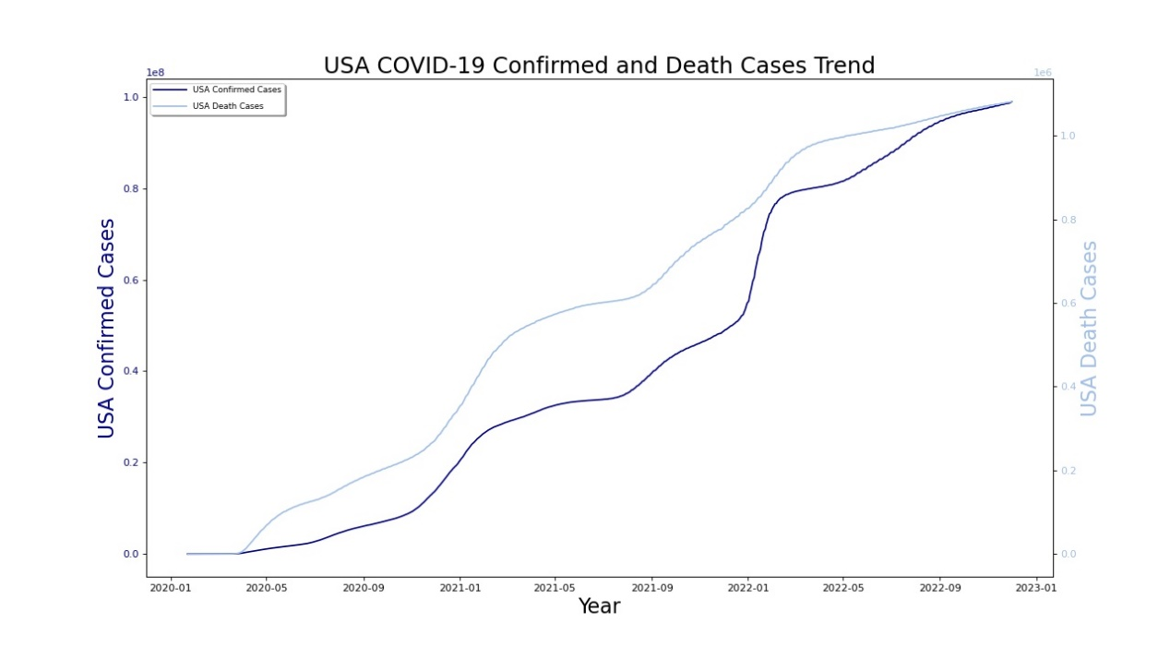

USA COVID-19 Confirmed, and Death Cases are depicted by this Line Graph.

USA Confirmed Cases are denoted by a dark blue line, and USA Death Cases are denoted by a light blue line.

The USA Death Cases graph is higher than the USA Confirmed Cases graph.

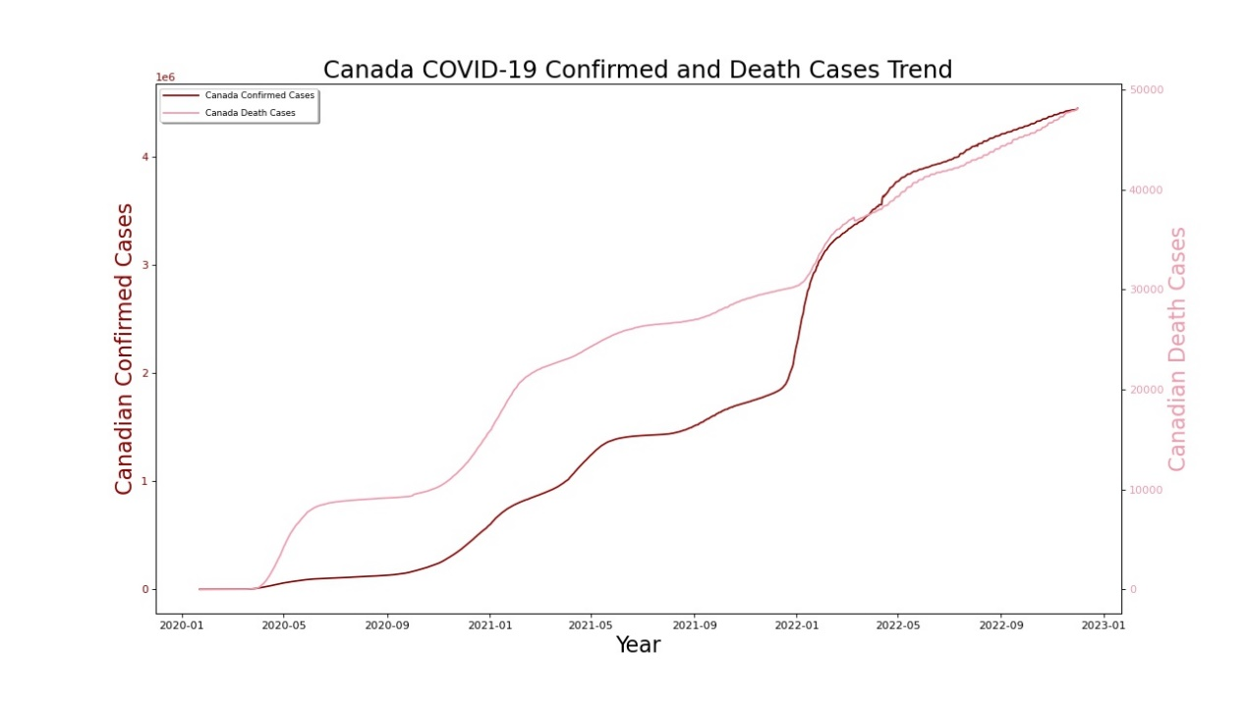

This line graph shows the confirmed and fatal COVID-19 cases in Canada.

Canada Death Cases are indicated by the Light Coffee Line, and Canada Confirmed Cases are indicated by the Dark Coffee Line.

The Canada Death Cases graph is higher than the Canada Confirmed Cases graph, while the Canada Confirmed Cases began gradually until 2022 before rapidly increasing until 2023.

